



CCTV

|  |  |
| --- | --- |
| Policy updated by | N Anderson |
| Reviewed by staff: | Nov 2022 |
| Review due: | Nov 2024 |
| Agreed by Headteacher: | N Anderson |
| Agreed by Management Committee: | Ratified |

This page is left intentionally blank.

**Introduction**

The Primary PRU fully recognises the contribution it can make to protect children, their parents / carers and visitors to the school. In order to comply with the law on the use of CCTV equipment, images recorded on the system may also be used for the purpose of crime prevention and detection, and may be provided to law enforcement agencies, if requested. For these reasons The Primary PRU operates CCTV equipment on its site. The aim of the policy is to explain the reasons for, and circumstances in which CCTV will be used to fulfil these functions.

**Centre Information**

Internal CCTV cameras will be located in the following locations:

1. Entrance Lobby rear right corner

2. Front right-side corridor on the right-side wall

3. Hall in the right corner

4. Front left side corridor on the right-side wall

5. Hawks room front right corner

6. Pod Room front right corner

7. Eagles room front right corner

8. Kitchen corridor front left corner

9. Canteen front right corner

10. Falcons corridor rear wall

11. Falcons room rear right corner

12. Owls classroom front right corner

13. Quiet Room front right corner

14. General Office rear left corner

15. Behaviour Mentor Office

External cameras will be located:

1. On the front external corner outside ladies WC, to view across the car park and entrance gate

2. On the rear right corner outside resource room, to view across the playground

3. On the rear right elevation outside Hawks classroom, to view the rear recessed area and playground

The CCTV system comprises dome cameras, with infrared sensors. The CCTV system is owned and operated by the school, the deployment of which is determined by the school’s leadership team. The CCTV will be monitored centrally from the school offices by the School Business Manager, the ICT technician, the Headteacher, and the Deputy Headteacher. In the absence of the Headteacher, the role of Data Controlling officer is delegated to the most senior member of the Senior Leadership Team on site. The CCTV cameras also record audio.

Any changes to CCTV monitoring will be subject to consultation with staff and the school community.

The school’s CCTV Scheme is registered with the Information Commissioner under the terms of the Data Protection Act 2018. The use of CCTV, and the associated images and any sound recordings is covered by the Data Protection Act 2018. This policy outlines the school’s use of CCTV and how it complies with the Act.

All authorised operators and employees with access to images are aware of the procedures that need to be followed when accessing the recorded images. All operators have been trained in their responsibilities under the CCTV Code of Practice. All employees are aware of the restrictions in relation to access to, and disclosure of, recorded images.

What our CCTV system can be used for:

* To help protect pupils, staff and visitors, using the Primary PRU, to ensure they are safe and not in any danger of harm.
* To help protect the Primary PRU from criminal damage or acts caused by those using them, or intruders.
* To help in the prevention of, or investigation of crime.
* To support staff training relating to physical intervention (with explicit permission from those parties affected).
* To support pupils’ SEMH needs by allowing them to reflect on own behaviour, and to support restorative justice.
* To help protect pupils and staff through the investigation of allegations.

What our CCTV system cannot be used for:

* Covert surveillance.
* Tracking of individuals without their knowledge.
* Observation of employees for the purpose of performance management / assessment.

**Statement of Intent**

The school complies with Information Commissioner’s Office (ICO) CCTV Code of Practice to ensure it is used responsibly and safeguards both trust and confidence in its continued use. The Code of Practice is published at:

<https://ico.org.uk/for-organisations/guide-to-data-protection/key-dp-themes/guidance-on-video-surveillance-including-cctv/about-this-guidance/>

CCTV warning signs will be clearly and prominently placed at all external entrances to the school, including school gates if coverage includes outdoor areas. Signs will contain details of the purpose for using CCTV (see appendix B). In areas where CCTV is used, the school will ensure that there are prominent signs placed at both the entrance of the CCTV zone and within the controlled area.

The planning and design has endeavoured to ensure that the Scheme will give maximum effectiveness and efficiency but it is not possible to guarantee that the system will cover or detect every single incident taking place in the areas of coverage.

**Siting the Cameras**

Cameras will be sited so they only capture images relevant to the purposes for which they are installed (described above) and care will be taken to ensure that reasonable privacy expectations are not violated. The School will ensure that the location of equipment is carefully considered to ensure that images captured comply with the Data Protection Act.

The PRU will make every effort to position cameras so that their coverage is restricted to the school premises, which may include outdoor areas.

CCTV will be used in classrooms and in areas within school that have been identified by staff and pupils as not being easily monitored. CCTV will be used in spaces where pupils may be left alone when they are distressed, in order to facilitate passive supervision for their own safety. The staff member placing a student in such areas retains responsibility for supervision, unless they explicitly delegate this to another staff member.

Members of staff should have access to details of where CCTV cameras are situated.

**Storage and Retention of CCTV images**

Recorded data will not be retained for longer than is necessary. While retained, the integrity of the recordings will be maintained to ensure their evidential value and to protect the rights of the people whose images have been recorded.

At the Primary PRU, recorded data will be stored for 28 days. All retained data will be stored securely. Under certain circumstance, eg a criminal element, we would retain CCTV recordings until the particular situation has been finalised.

**Access to CCTV images**

Access to recorded images will be restricted to those staff authorised to view them, and will not be made more widely available.

All access will be carefully documented.

**Subject Access Requests (SAR)**

Individuals have the right to request access to CCTV footage relating to themselves under the Data Protection Act.

All requests should be made to the Leicester City Council Information Governance Team. Individuals submitting requests for access will be asked to provide sufficient information to enable the footage relating to them to be identified. For example, date, time and location. They will be asked to complete a ‘Subject Access Request Form’.

The school reserves the right to refuse access to CCTV footage where this would prejudice the legal rights of other individuals or jeopardise an on-going investigation.

**Access to and Disclosure of Images to Third Parties**

There will be no disclosure of recorded data to third parties other than to authorised personnel such as the Police and service providers to the school where these would reasonably need access to the data (e.g. investigators). Requests should be made in writing to the Headteacher. The data may be used within the school’s discipline and grievance procedures as required, and will be subject to the usual confidentiality requirements of those procedures.

**Complaints**

Complaints and enquiries about the operation of CCTV within the school should be directed to the Headteacher in the first instance.

**Further Information**

Further information on CCTV and its use is available from the following:

Surveillance Camera Code of Practice Updated Jan 2022

www.ico.gov.uk

Regulation of Investigatory Powers Act (RIPA) 2000

Data Protection Act 2018

**Appendix A - Checklist**

This CCTV system and the images produced by it are controlled by the Headteacher, who is responsible for how the system is used and for notifying the Information Commissioner about the CCTV system and its purpose (which is a legal requirement of the Data Protection Act 2018).

Leicester City Primary PRU has considered the need for using CCTV and have decided it is required for the prevention and detection of crime and for protecting the safety of customers. It will not be used for other purposes. We conduct an annual review of our use of CCTV.

|  |  |  |
| --- | --- | --- |
| **Checked (Date)** | **By** | **Date of next review** |
| Notification has been submitted to the Information Commissioner and the next renewal date recorded. |  |  |
| There is a named individual who is responsible for the operation of the system. |  |  |
| A system had been chosen which produces clear images which the law enforcement bodies (usually the police) can use to investigate crime and these can easily be taken from the system when required. |  |  |
| Staff and members of the school community will be consulted about the proposal to install CCTV equipment. |  |  |
| Cameras have been sited so that they provide clear images. |  |  |
| Cameras have been positioned to avoid capturing the images of persons not visiting the premises. |  |  |
| There are visible signs showing that CCTV is in operation. Where it is not obvious who is responsible for the system contact details are displayed on the sign(s). |  |  |
| Images from this CCTV system are securely stored, where only a limited number of authorised persons may have access to them. |  |  |
| The recorded images will only be retained long enough for any incident to come to light (e.g. for a theft to be noticed) and the incident to be investigated. |  |  |
| Except for law enforcement bodies, images will not be provided to third parties. |  |  |
| The organisation knows how to respond to individuals making requests for copies of their own images. If unsure the controller knows to seek advice from the Information Commissioner as soon as such a request is made. |  |  |
| Regular checks are carried out to ensure that the system is working properly and produces high quality images. |  |  |

**Appendix B – CCTV Signage**

It is a requirement of the Data Protection Act 2018 to notify people entering a CCTV protected area that the area is monitored by CCTV and that pictures are recorded. The school is to ensure that this requirement is fulfilled.

**The CCTV sign should include the following:**

* That the area is covered by CCTV surveillance and pictures / audio are recorded
* The purpose of using CCTV
* The name of the school
* The contact telephone number or address for enquiries

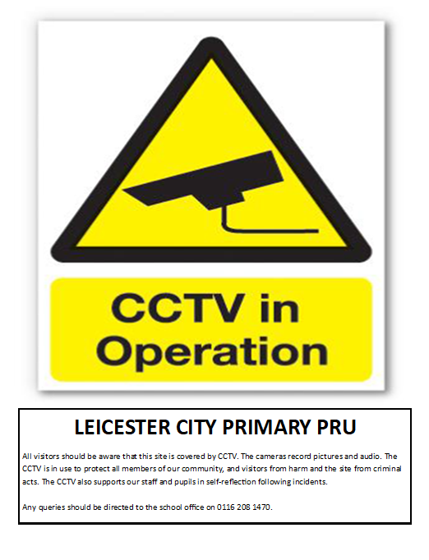

**CCTV – Leicester City Primary PRU**

REQUEST TO VIEW CCTV IMAGES

**Name of Person requesting access:**

Print Name:_______________________ Designation :______________________

Signed:_________________________ Date of Request: **_____/_____/_____**

**Reason for Request to view the Image(s):**

Please give as much detail as possible, including dates / times / locations of images required.

**Authorisation Granted by Headteacher or Delegated Senior Leader:**

 YES  NO Signed : ___________________________

Date: ____/_____/______

If access is not granted, give the reason for refusal:

**CCTV – Leicester City Primary PRU**

RECORD OF VIEWING ACCESS PROVIDED TO CCTV IMAGES

**Date and Time Image Viewed:**

Date: ______/______/______________ Time: _________________________

**Name of Persons Viewing the Image:**

**Name:** **Designation:**

_________________________ _________________________

_________________________ _________________________

_________________________ _________________________

_________________________ _________________________

**Reason for the Viewing:**

**Outcome, if any, of the Viewing:**

__________________________________________________________________________________________________________________________________________________________________________________________________________________________________________________________________________________________________________________________________________________________________________________________________________________

Signed: _______________________ PRINT NAME _______________________

Date:______/______/______